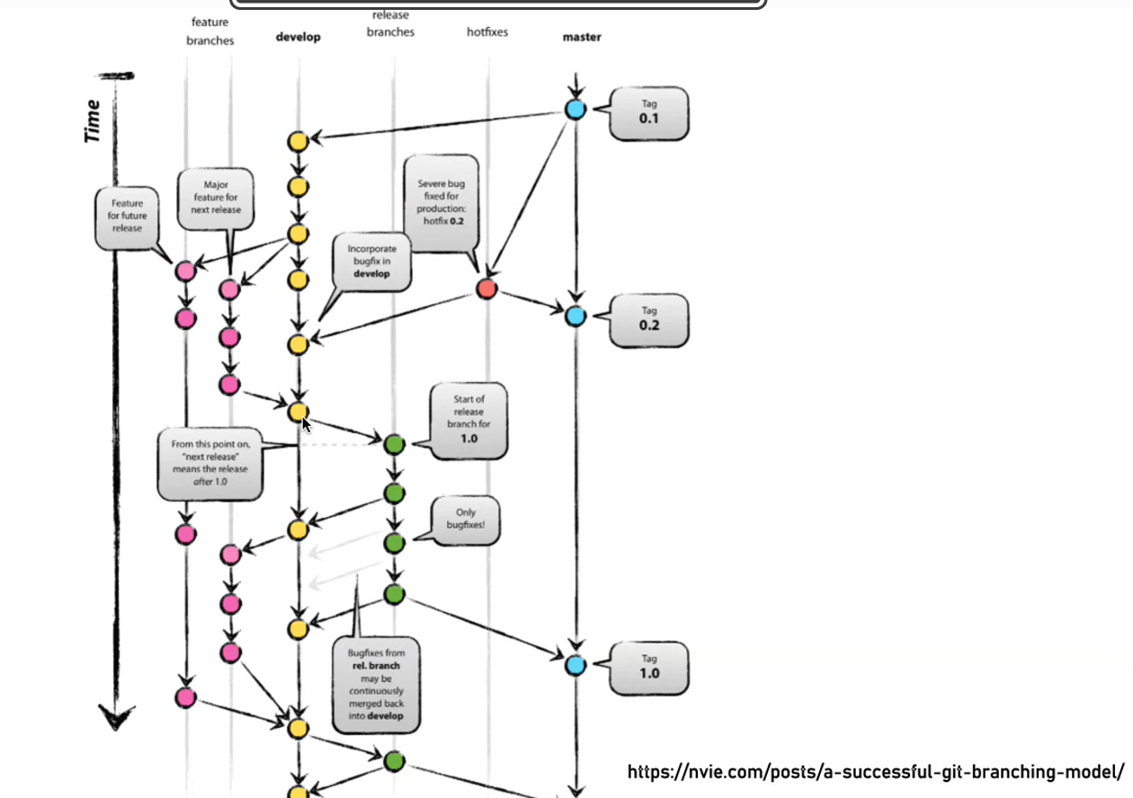

Resources
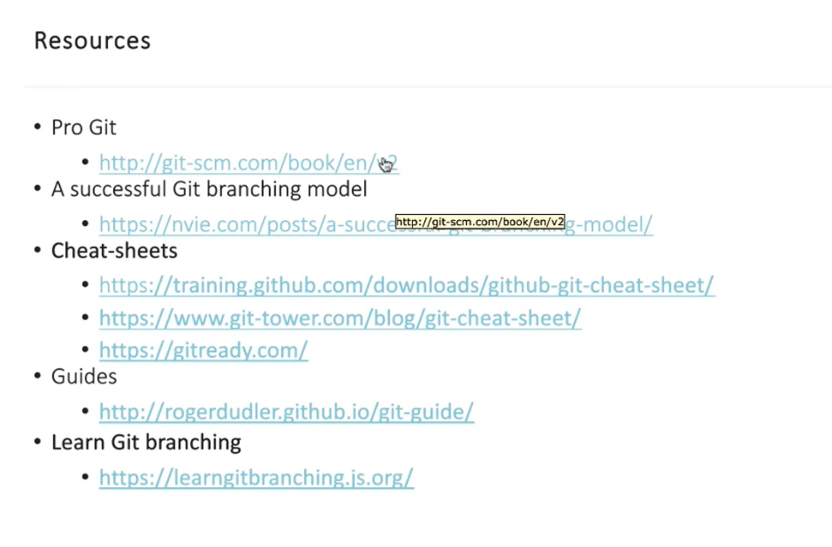

- git commit –amend -> add recenty staged file in the last commit.
Git DEEP COURSE

- Everything in the git is done using hashes and hashing. That is SHA hash system
Commit is just a type of a commit.

- tree : the way in which git stores directories in easy commit
and easch commit referes to a commit tree
- blob : the way git stores files.
in each commit tree there are blobs

- Git stores snapshot of files on a per commit level. Therefore to not cause too much memory stree it compresses and and packs each files to store them more efficiently.
- If file does not change between the commit the file does not change. And git deduplicate the files not changed.
- Ie for every commit for every non file changed, git create a new reference pointer to the file and stores it into the tree.
- This way you can move to prevoisly changed shit.

By gpt :
Git internals — nutshell
- Git is a content-addressable system: everything is stored using SHA hashes.
- A commit is an object that points to a tree.
- A tree represents a directory structure.
- A blob represents file contents.
- Each commit stores a snapshot of the project, not file diffs.
- Git deduplicates data: identical files are stored once, even across many commits.
- Git uses compression and packing to reduce disk usage.

How Git handles commits & file changes (short)
When a file changes
- Git hashes the new file content.
- A new blob is created for that content.
- The commit’s tree points to this new blob.
- A new commit object is created that references this tree.
---- When a file does NOT change
- Git does nothing to the file content.
- The new commit’s tree simply reuses the existing blob hash.
- No extra storage is used for unchanged files.
- Git copies the references (hashes), not the blob data itself. From the previous commit tree and stores in the new commit tree.
- This is why Git is fast, space-efficient, and lets you easily move back to previous versions.

How git merge works?
- For both the branches it finds the most recent common ancestor. Or merge base.
- Replay the changes from the both branches eg (main and feature_branch).
- Create a new commits including having two branches last commits as the parent. Create a three way merge operation.
Git performs a 3-way merge using:
The merge base
The tip of the current branch
The tip of the branch being merged
If the changes don’t overlap → merge is automatic.
If the same lines were modified differently → merge conflict.

Merge verses Rebase
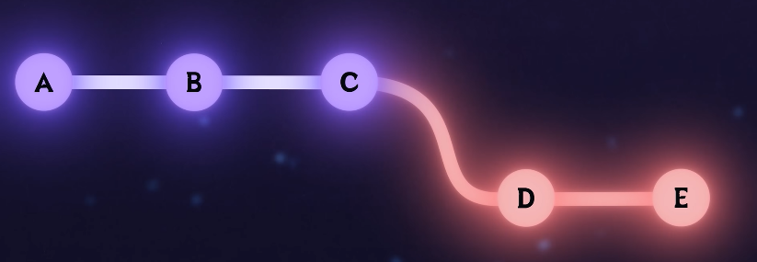
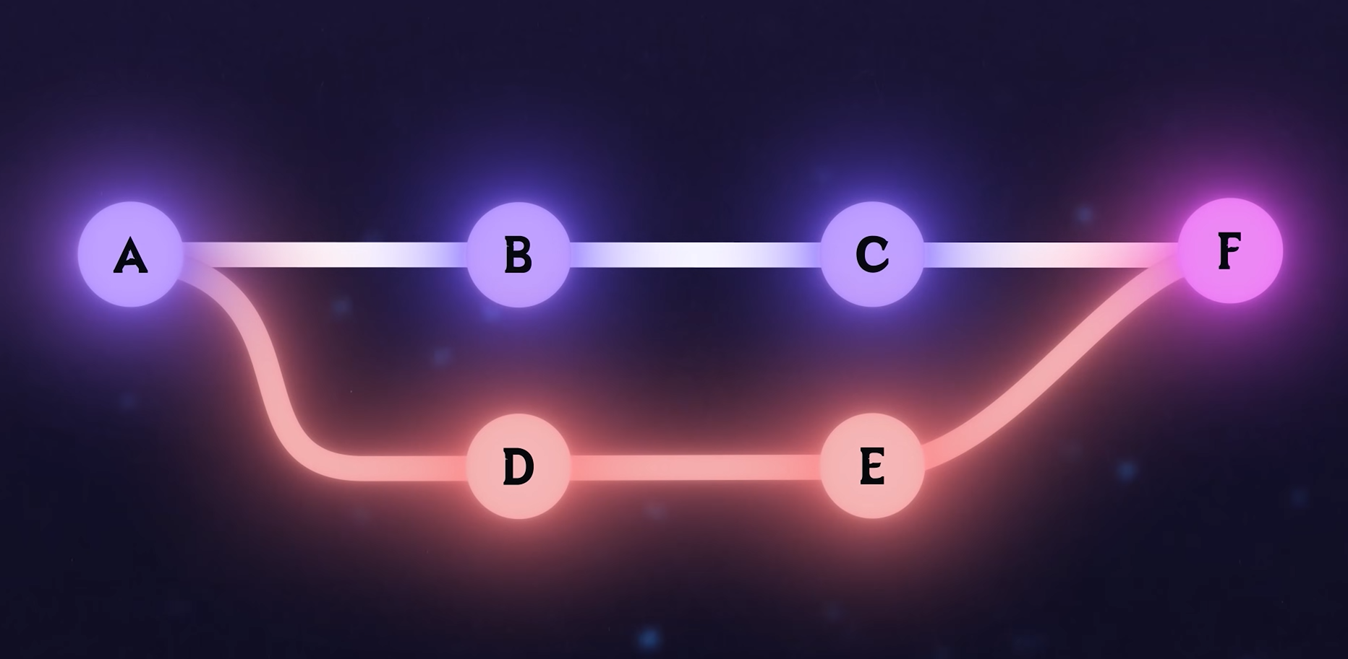
Reabase allows merge commit free history. These kind of the things are let us known by the lead dev and we can manage these things from there.
If theres a conflit while rebasing theres conflict while committing.
You should never rebase onto the main branch this would create lot of issues for other developers.

git remote means “a link to another copy of your repository.”
origin is the default remote name
It usually points to something like a GitHub repo
So when you write the Git remote add origin # you are adding a link named origin to a “copy of the repo”….
So there no authoratatice repo, you just have copies of the repo and you can just switc and merge these shits among themselves.

Git push :
Pushes local changes onto a remote any remote.
Eg: git push origin main //pushes the changes onto the origins main branch

Do for example when you write
git pull origin main -> pull changes from the remote copys main branch onto the local system
Open sourse shit
- Fork
- Create branches
- Make changes in the branch

GIT and Collaboration
- Fork is not a real thing in git, it’s a feature provide by GitHub, auto code, and GitLab.
- Reflog : monitors how with each of the commits the head has moved from place to place…

MERGE CONFLICT
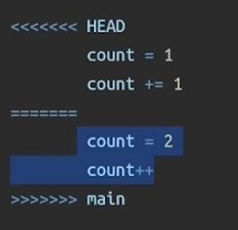
When conflict occurs git will manually ask you to keep and del the changes.
In the conflit file
<<<<Head to =================== is ours code ie. Top is mine
And =========== to >>>main is the branch we are merging ie. Bottom is their

- REBASE CONFLITS IS BULLSHIT (kinda)

SQUASH : compress changes from multiple commits into a single commit to keep the commit history clean.

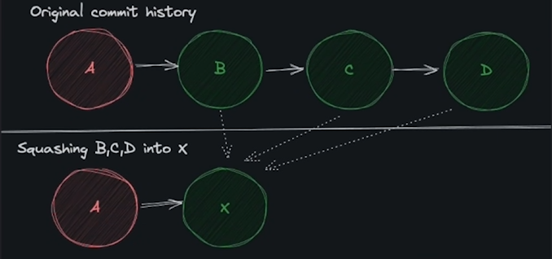

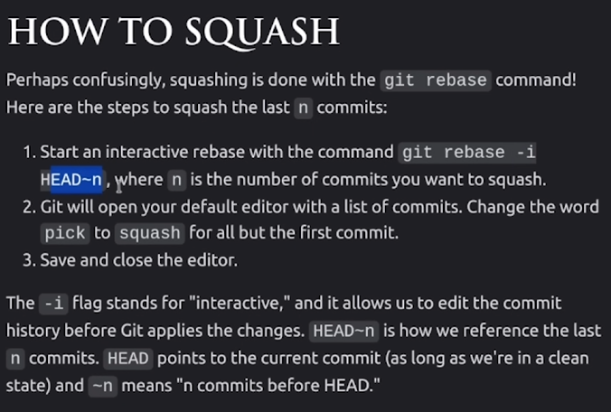
pick -> s (Pick is replaced by squash or s)
and those two commits are squashed into single commit
1qi

iiii

STASH : create a copy of your current workflow make some changes and you can then revert back to your original copy in the exact same state you left it in. same unstaged changes and commits….

Revert : undoes the changes but keep the commit history

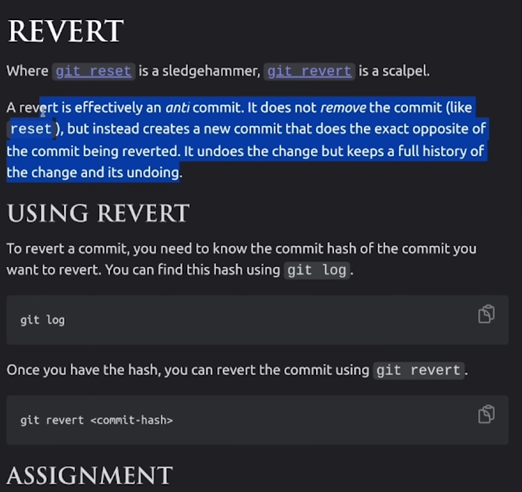

Cherry pick :-> when you want one or few changes from a branch but not the entire history of the branch…..
Git cherry-pick // put comiit hashes here onto the branch you want the changes in that branch to be integrated to…
You can pick and choose the commits you want to merge with another branch.

Bisect : -> this uses binary search on the branch to search for the commit you are actually looking into .
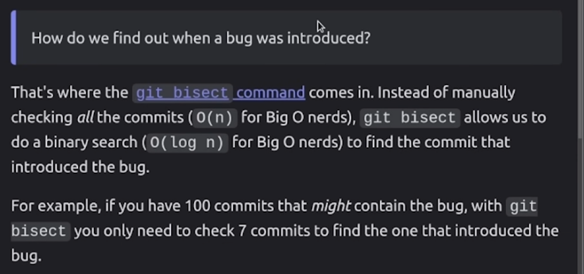
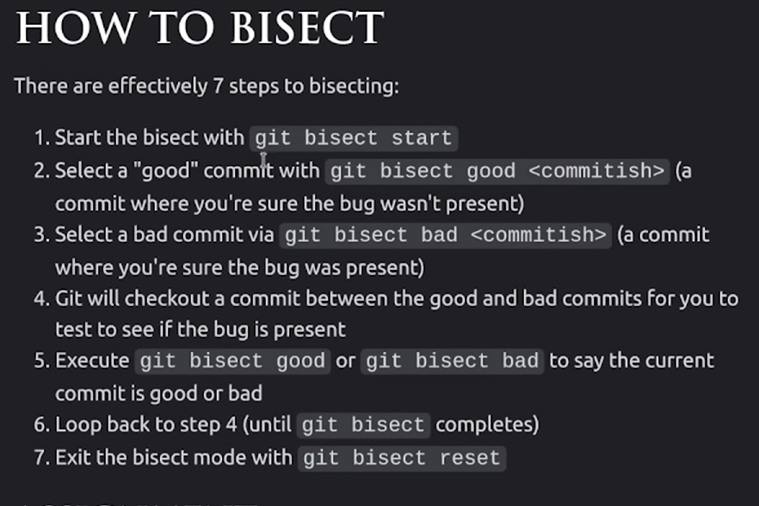
Greate when searching for the buggy commit long time ago in the history, or just looking for wheever the changes in the code base was made to get into the crux of the problem….

WORKTREE:
Git tag -> tag is just an immutable pointer to a commit so you can just move there anytime you want…. on the lastest commit it creates by default……
To create
git tag -a “//name” -m “// tag message”
usually, tags are and can be used to create version numbers and type shit……

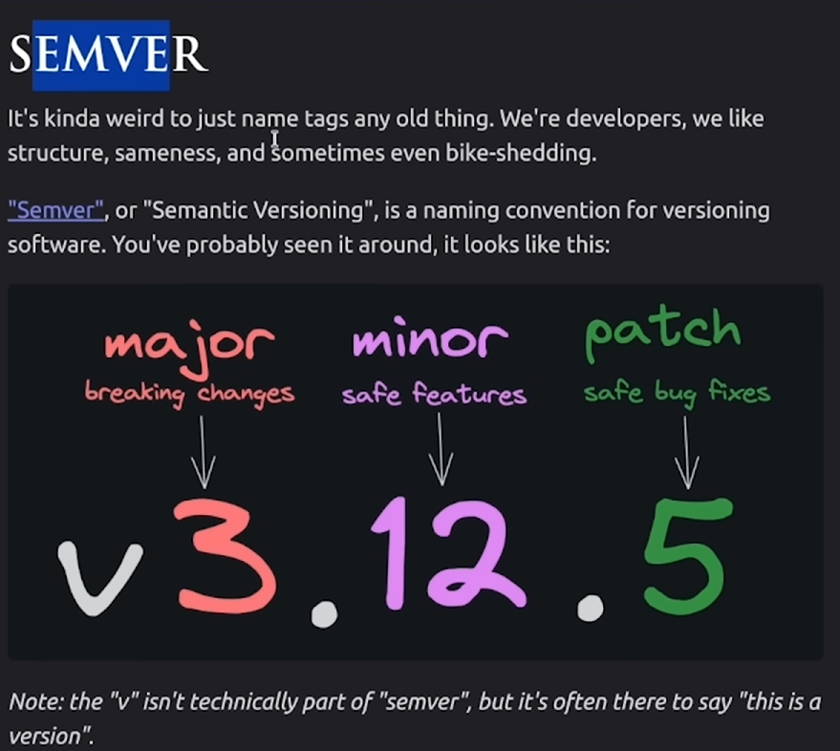
Semver naming convention:-> semantic versioning

MAJOR.MINOR.PATCH

Eg: git tag -a “v3.22.3” -m “fixed minor bug”
Git and GitHub - Full Course
SSH Tutorial - Crash Course
Git Cheat sheet -> Git Cheat Sheet

